# Start proyect

npm init

npm install express --save

npm install body-parser --save

npm install connect-multiparty --save (this is optional. This is for upload files)

npm install mongoose --save (this is depending of database you will use)

# install sequelize

reference:

<http://docs.sequelizejs.com/manual/installation/getting-started.html>

# install mongooseeder

https://www.npmjs.com/package/mongooseeder

npm install --save mongooseeder

create a folder called cr and index.js into folder models

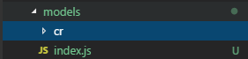

In index.js add

var fs = require('fs');

/*

* initializes all models and sources them as .model-name

*/

//models of core (folder cr)

fs.readdirSync(__dirname+'/cr').forEach(function (file) {

if (file !== 'index.js') {

var moduleName = file.split('.')[0];

exports[moduleName] = require('./cr/' + moduleName);

}

});

After create a folder in the main directory called seeds

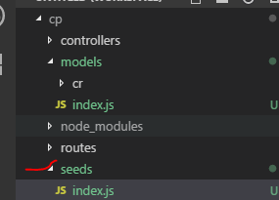

A code example of index.js

const mongoose = require('mongoose');

const mongooseeder = require('mongooseeder');

const models = require('../models');

const mongodbUrl = 'mongodb://localhost:27017/changeProducts';

mongooseeder.seed({

mongodbUrl: mongodbUrl,

models: models,

clean: true,

mongoose: mongoose,

seeds: () => {

// Run your seeds here

// Example:

return models.role.create([{

name: 'admin',

displayName: 'administrador'

},

{

name: 'user',

displayName: 'usuario'

}

]);

}

});

The model role is

'use strict'

var mongoose = require('mongoose');

var Schema = mongoose.Schema;

var RoleSchema = Schema({

name: String,

displayName: String

});

module.exports = mongoose.model('Role',RoleSchema);

finally run

node seeds

## install nodemon

this is for update changes while the server is running. This is a devdependencie because in production you do not need this. This is for the developer

npm i -D nodemon

after install it copy this to package.json

"start": "nodemon index.js",

to

"scripts": {

"start": "nodemon index.js",

"test": "echo \"Error: no test specified\" && exit 1"

},

This tell nodejs when the server is running by command npm start it will go to scripts in start and put nodemon index.js to run index.js with nodemon. With just npm start

## Create some files

Create index.js and app.js in the main directory

## Mongoose configuration

In C:\ add these folders

data/db

In app.js add

# Install socket

npm install socket.io --save

# Strange errors

If you are seeing a strange error, you can prove to end tasks in windows of node js